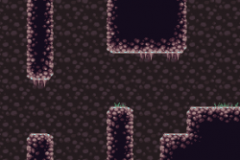Drop and Hop

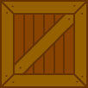Proposal – EE319k

Overview

Using a slider to control a block dispenser at the top of the screen, drop blocks to help your character navigate the stage.

Image result for heart icon pixel pngImage result for heart icon pixel pngImage result for heart icon pixel png

Basic Rules:

1. If your character falls of the stage you must restart the level.
2. The blocks have various properties such as bouncy blocks and smaller and larger blocks
3. The goal of the game is to progress to the end of each level in the shortest amount of time
4. Collect fruit to alter the gravity of the level (how high you can jump)
5. The level scrolls along at the pace of the level (character’s goal is to stay on the screen) if the character touches the edge of the screen, they lose a life.
6. Collect gems for more blocks to dispense
7. If a block is dropped onto the character’s head he dies and a life is lost.
8. If all three lives are lost then the character dies and the level is restarted.

Features

1. Character Movement: The character must be able to move left and right, jump, and the screen must shift such that he is in the middle of the screen
2. Block dispenser: at the top of the screen there will be a block dispenser that is used to drop various blocks to assist in navigating the stage.
3. Gravity: there is a persistent force of gravity downwards that varies based on certain blocks and fruit.
4. Enemies and spikes: dangers throughout the level that kill your character on touch.
5. Level end: at the end of a level there is a door to the next, the score is shown for the level and the game progresses to the next.

Difficulty

Depending on the structure and variation in levels, this could be a difficult game to code.

1. Physics engine involved
2. Control of weight and collision detection with multiple blocks.